**SmartIntern Long Term Virtual Internship**

An Internship Report submitted in partial fulfillment of the requirements for the award of degree of

**BACHELOR OF TECHNOLOGY**

## In

**MECH – MECHANICAL ENGINEERING**

**Submitted by:**

**VELAMALA RAVINDRA 20W61A0330**

**MAMIDI JAYADEV 21W65A0315**

**PANAPANA RANJITH 21W65A0318**

**PUTI ANIL KUMAR 20W61A0322**



**Department Of Mechanical Engineering**

**SRI SIVANI COLLEGE OF ENGINERING**

**Approved By AICTE & Affiliated to JNTUGV**

**Chilakapalem Jn., Srikakulam 532402**

**An Android Application For Keeping Up With The Latest Headlines**

**Required Initial Steps**

This milestone explains about Required initial steps: https://developer.android.

**Creating A New Project :**

**Steps need to be followed:**

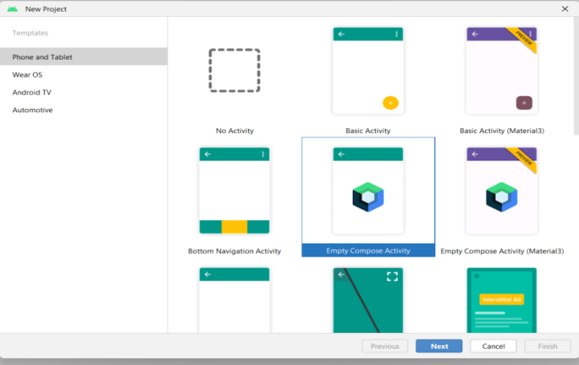

Step 1 : Android studio > File > New > New Project > Empty Compose Activity

Step 2 : Click on **Next** button.

Step 3 : Give name to the new project.

Step 4 : Give the Minimum SDK value

Step 5 : Click Finish

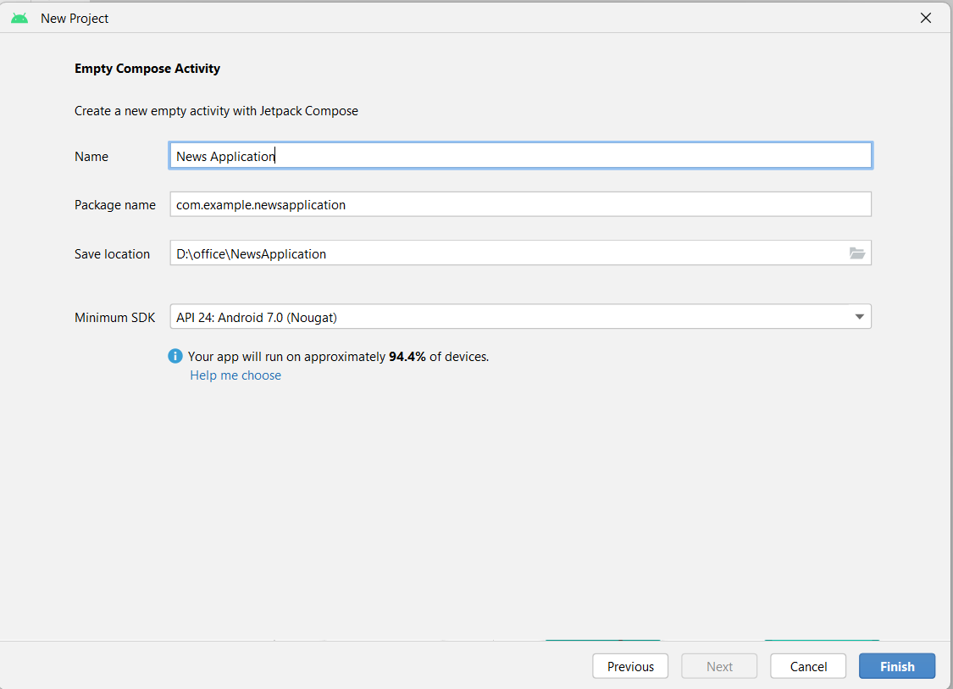

**Main activity file**

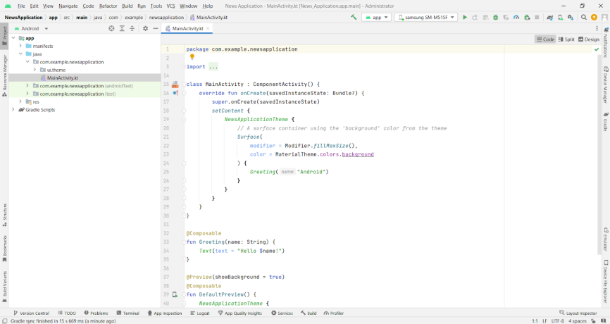

### Adding Required Dependencies

**Gradle Scripts > Build.Gradle(Module :App)**

**Gradle scripts > build.gradle(Module :app)**

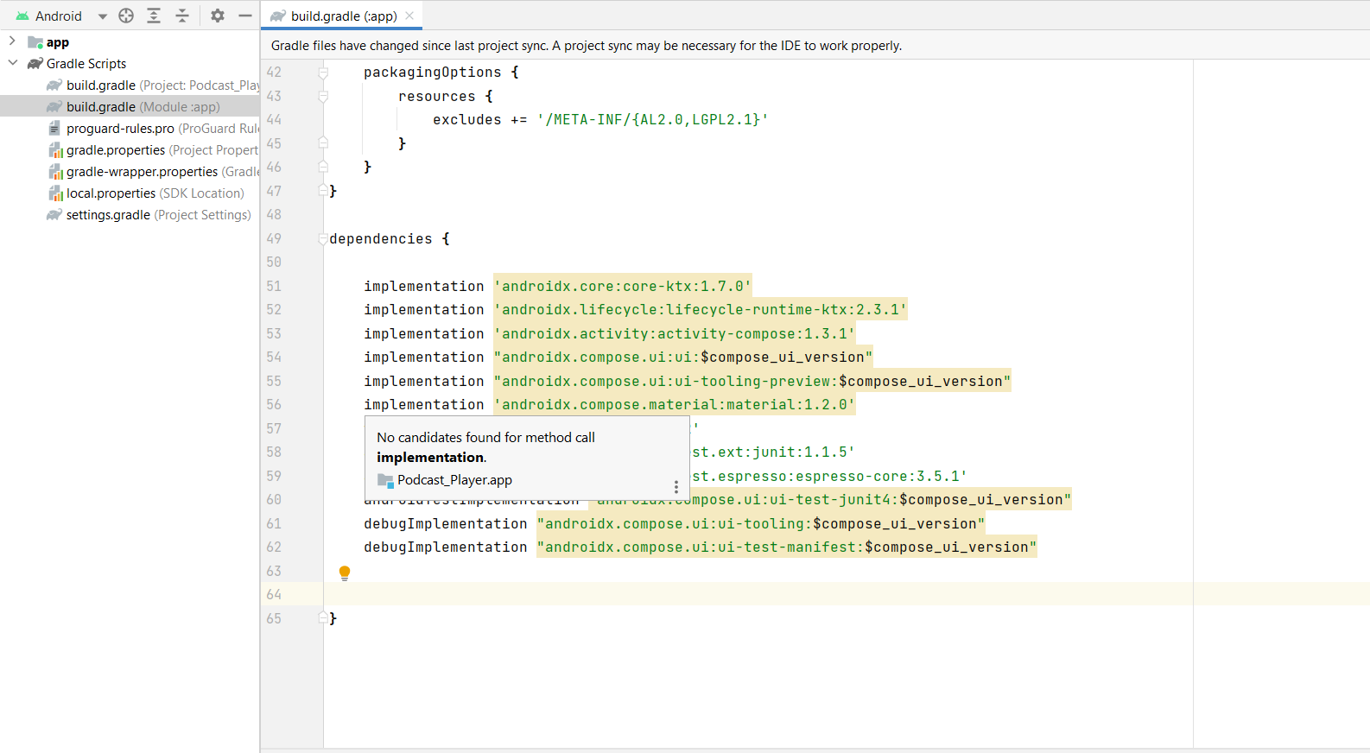

**Adding Retrofit Dependencies**

**Adding Retrofit dependencies**

*// Retrofit*

implementation 'com.squareup.retrofit2:retrofit:2.9.0'

implementation "com.squareup.okhttp3:okhttp:5.0.0-alpha.2"

implementation 'com.squareup.retrofit2:converter-gson:2.9.0'

**Adding Coil Dependencies**

implementation("io.coil-kt:coil-compose:1.4.0")

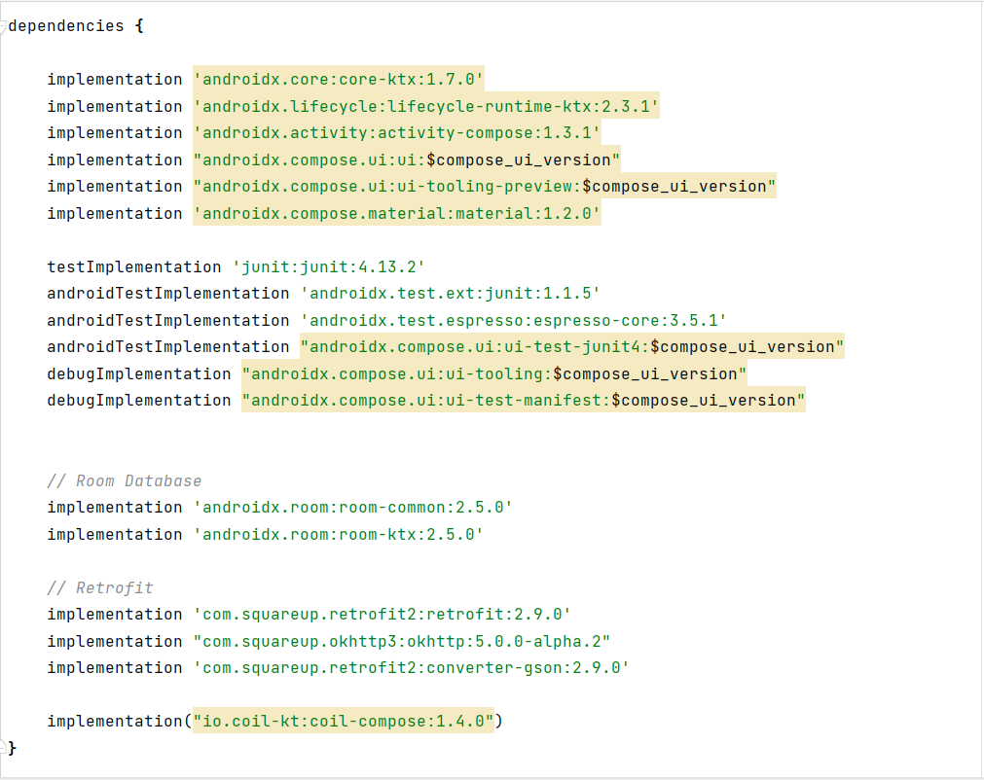

Click on Sync now.

**Adding Permissions**

This milestone explains about adding permissions.

**Creating The Database Classes**

To learn more about Database follow this link:

<https://gorillalogic.com/blog/android-room-tutorial-simplifying-how-you-work-with-app-data/>

**Create User Data Class**

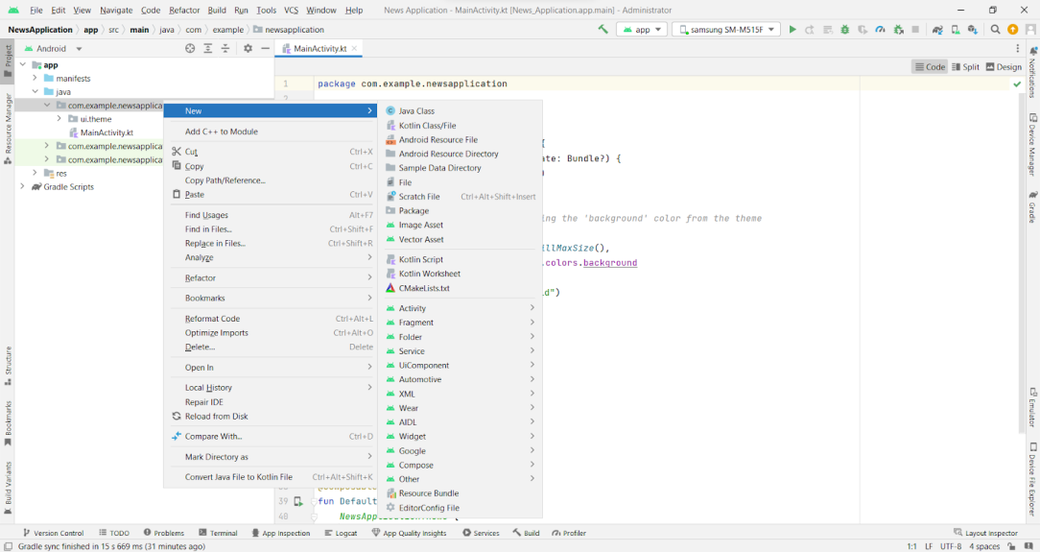

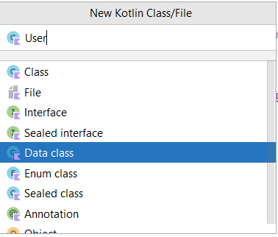

User class code:

<https://github.com/smartinternz02/NewsHeadlines/blob/main/app/src/main/java/com/example/newsheadlines/User.kt>

**Create An UserDao Interface**

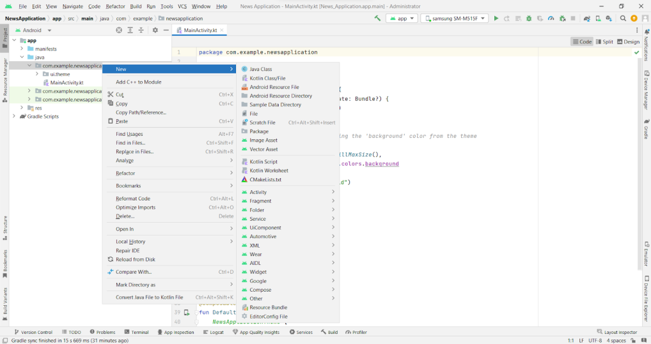

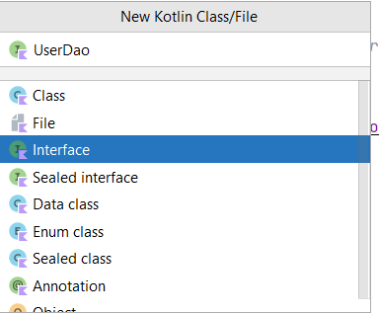

**UserDao interface code:**

<https://github.com/smartinternz02/NewsHeadlines/blob/main/app/src/main/java/com/example/newsheadlines/UserDao.kt>

**Create A API Key For The Required API**

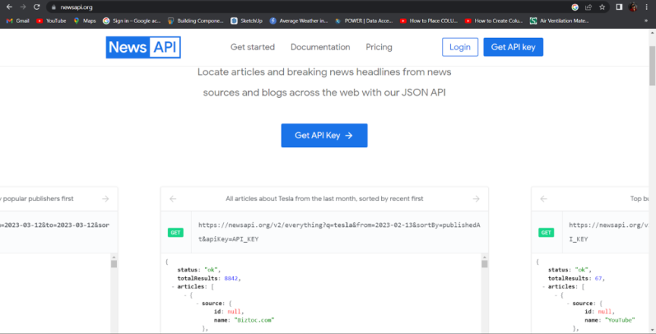

* **Code which is needed to copy:**

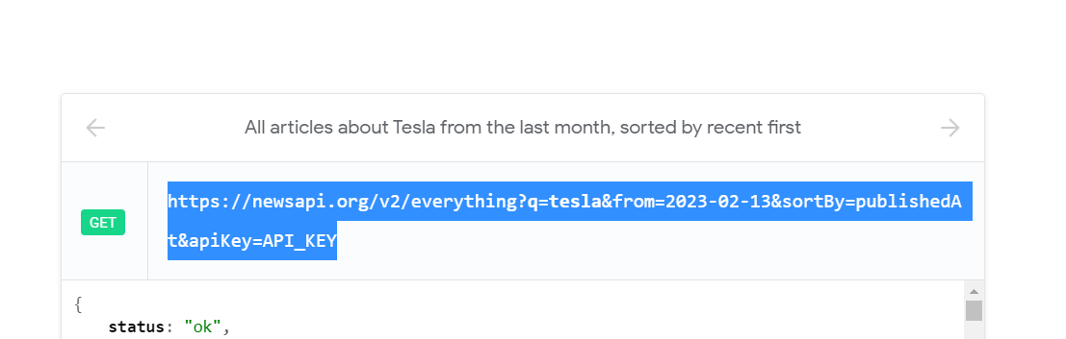

**Enter the API key at API_KEY to get the complete json file.**

**Json File:**

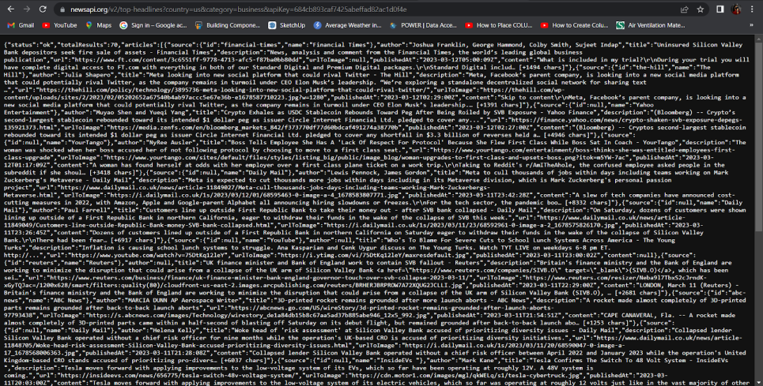

**Copy And Paste The Complete Json File To Json2kt.Com**

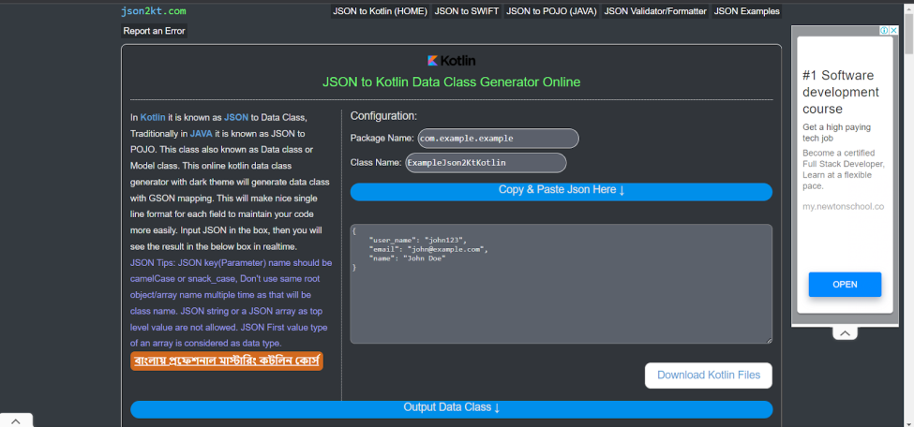

**Click on Output Data class**

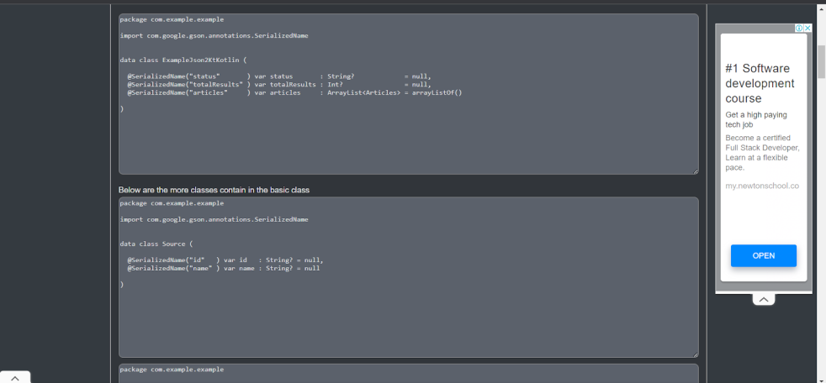

Now use this classes in android studio

**Database For News Integration Into Project**

**Create ApiService Interface**

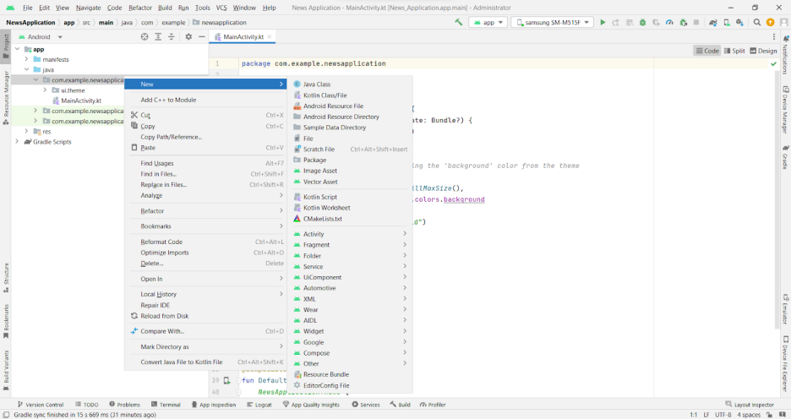

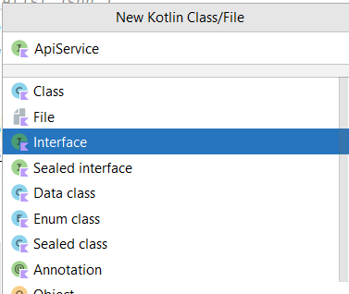

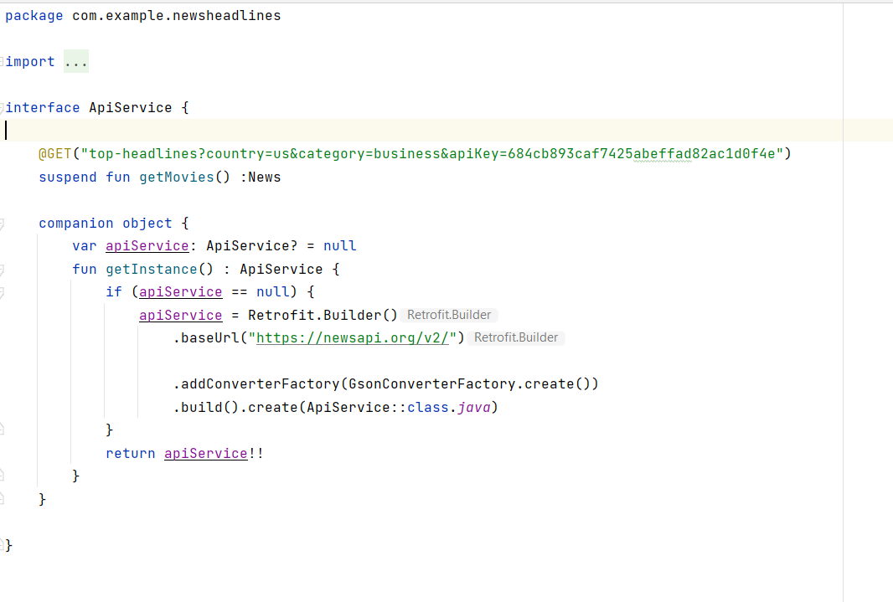

**Create Model Data Class**

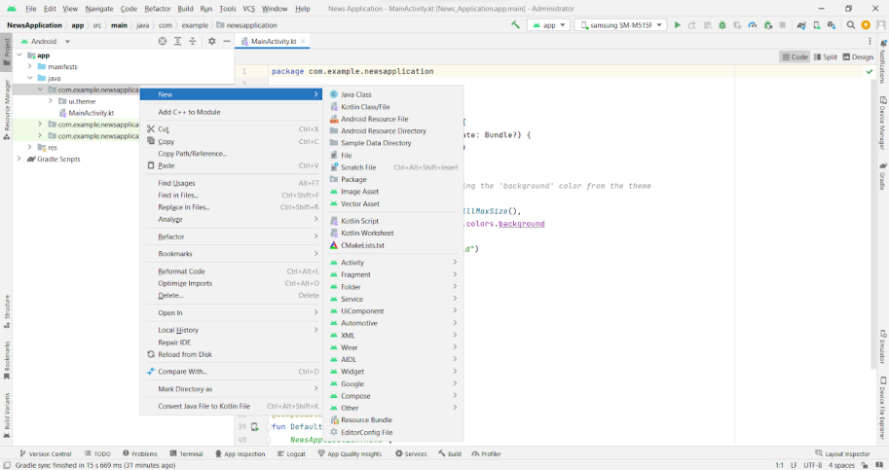

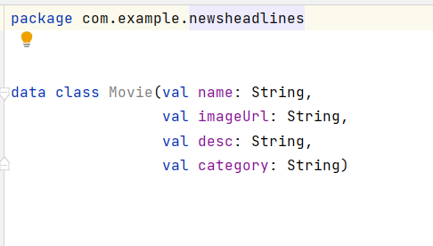

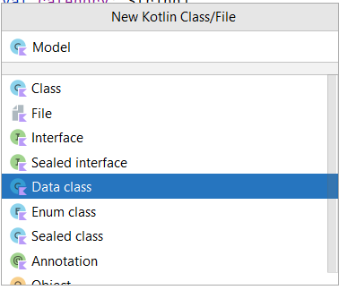

**Create News Data Class**

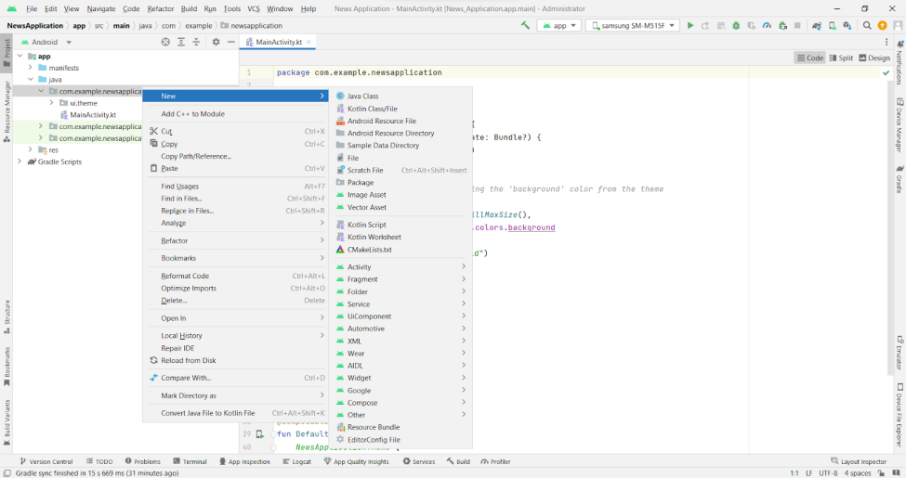

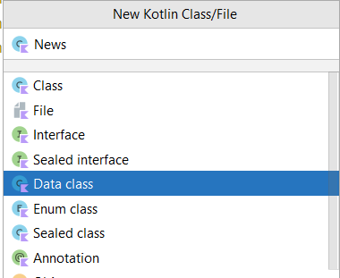

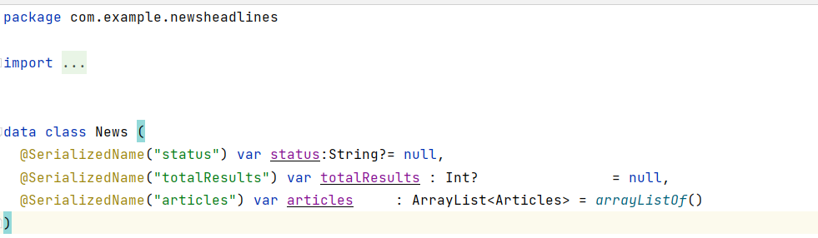

**Create Source Data Class**

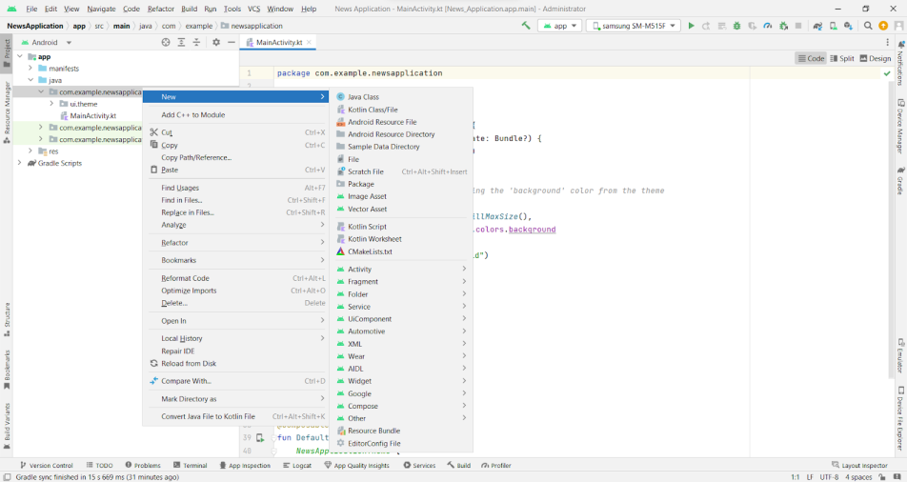

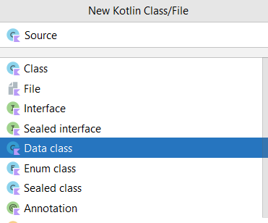

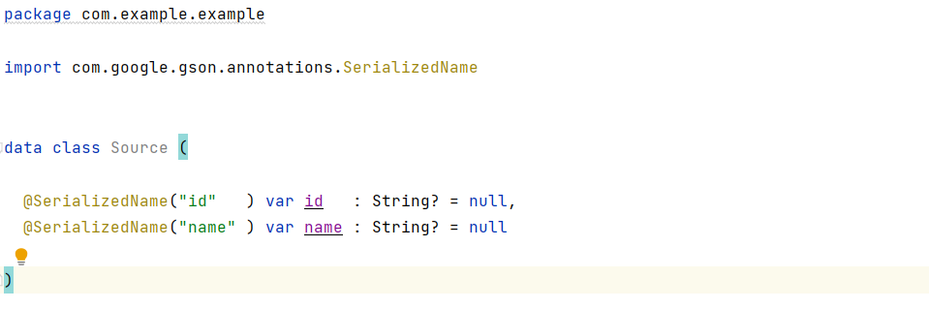

**Create Articles Data Class**

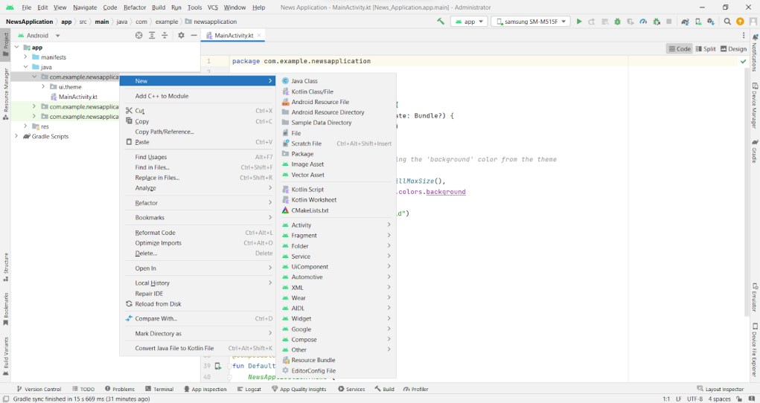

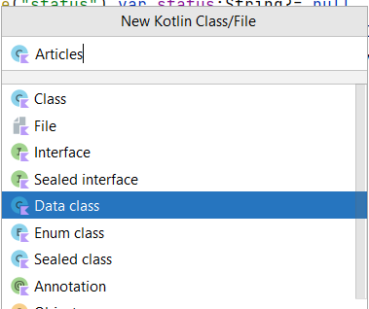

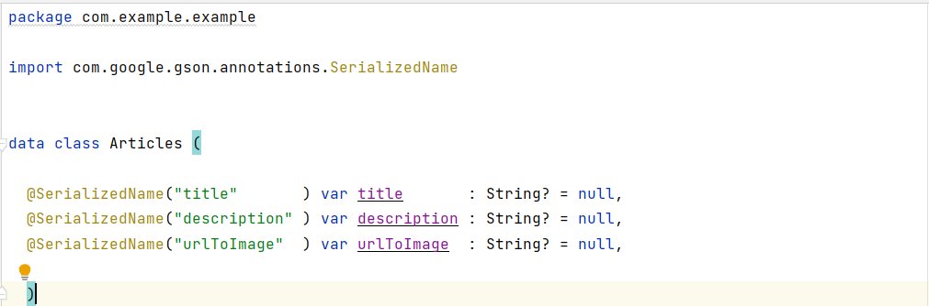

**Create MainViewModel Class**

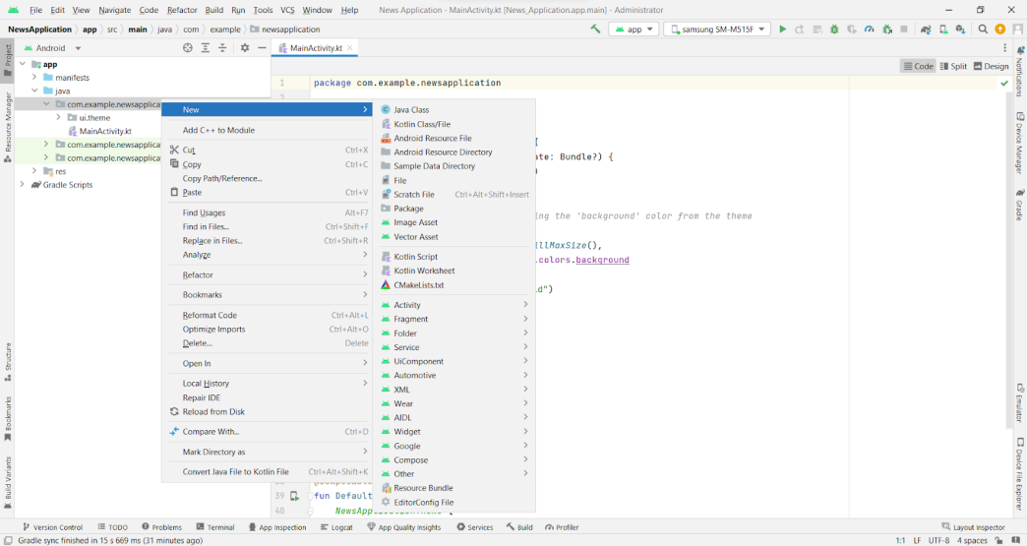

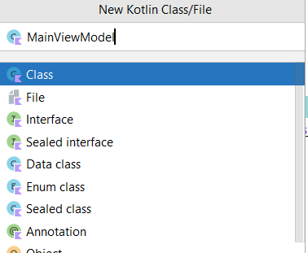

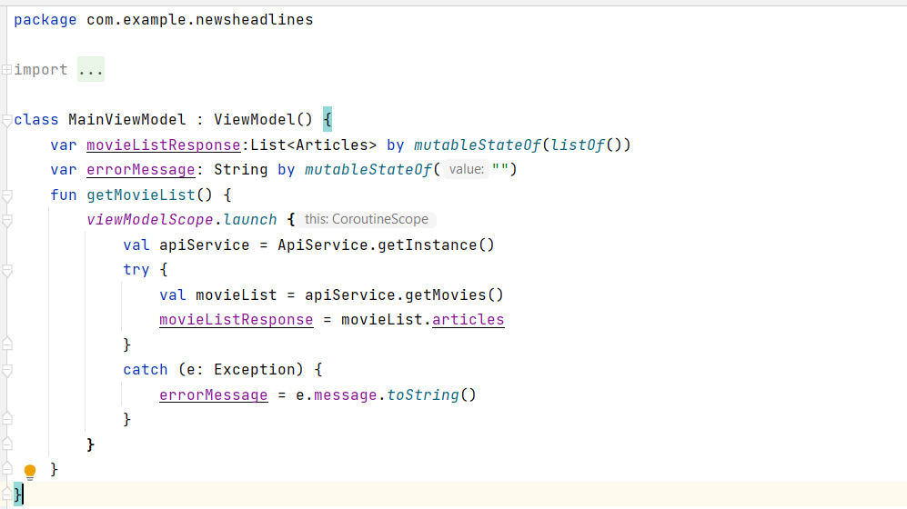

**Building Application UI And Connecting To Database**

This milestone explains about building application UI and connecting to database.

**Creating RegistrationActivity.Kt With Database**

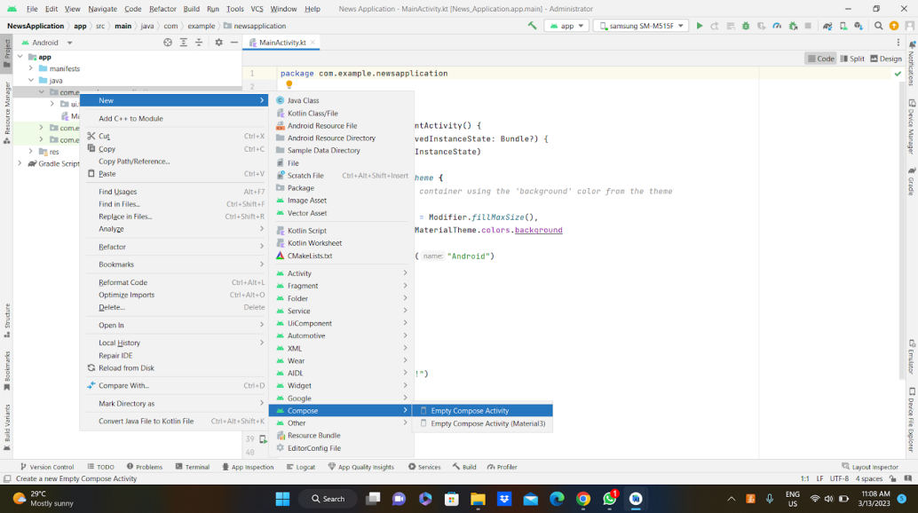

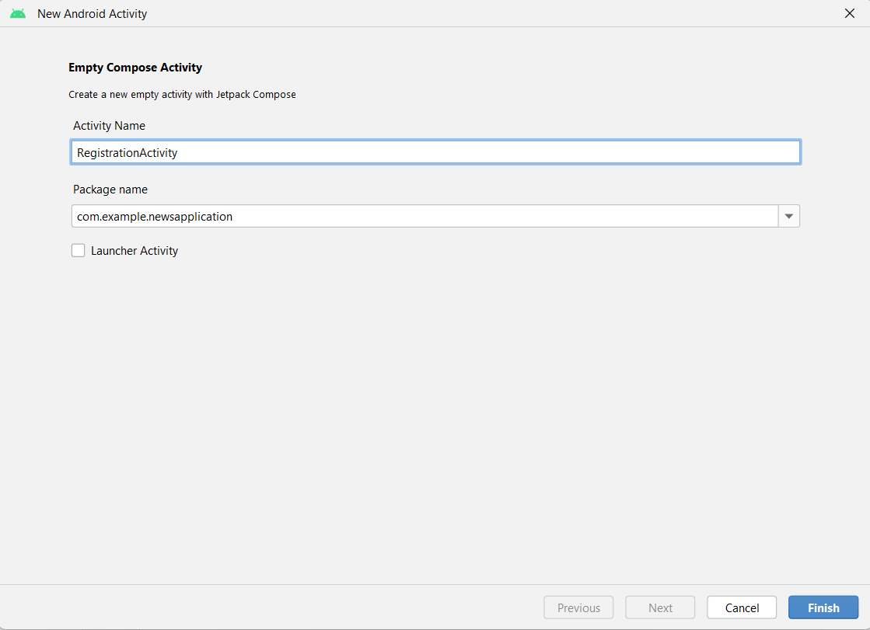

**Database connection in RegistrationActivity.kt**

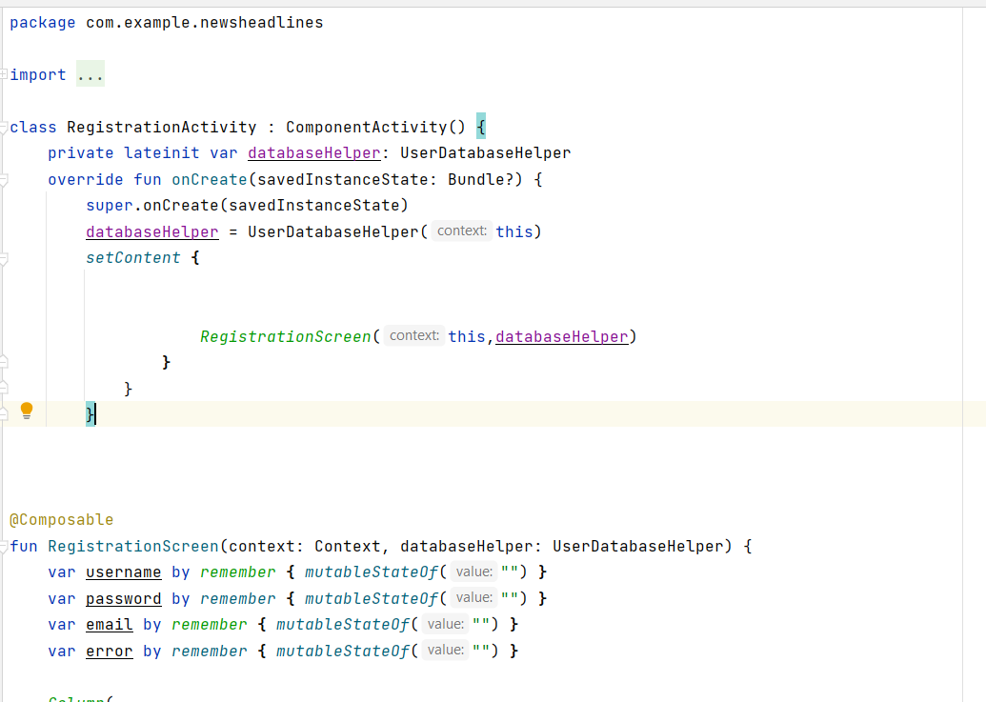

**Creating RegistrationActivity.Kt With Database**

**Creating RegistrationActivity.kt with database**





**Database connection in RegistrationActivity.kt**



**Complete code in below link:**

<https://github.com/smartinternz02/NewsHeadlines/tree/main/app/src/main/java/com/example/newsheadlines/RegistrationActivity.kt>

**Download the required drawable from the code:**

<https://github.com/smartinternz02/NewsHeadlines/tree/master/app/src/main/res/drawable>

**Download the nodpi images from drawablenodpi :**

<https://github.com/smartinternz02/NewsHeadlines/tree/master/app/src/main/res/drawable-nodpi>

**Required drawables**

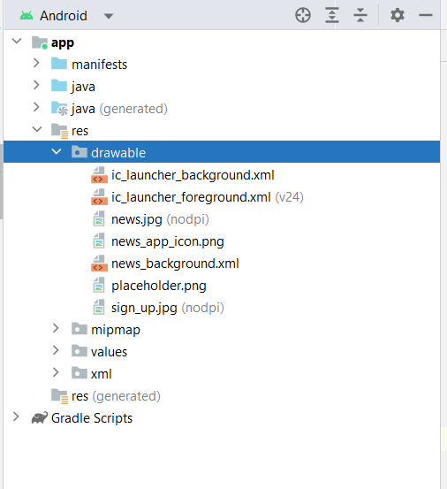

After add all this we need to create the UI in MainActivity.kt file

MainActivity.kt file

Complete MainActivity.kt code:

<https://github.com/smartinternz02/NewsHeadlines/blob/main/app/src/main/java/com/example/newsheadlines/MainPage.kt>

Linking MainActivity with DisplayNews.kt

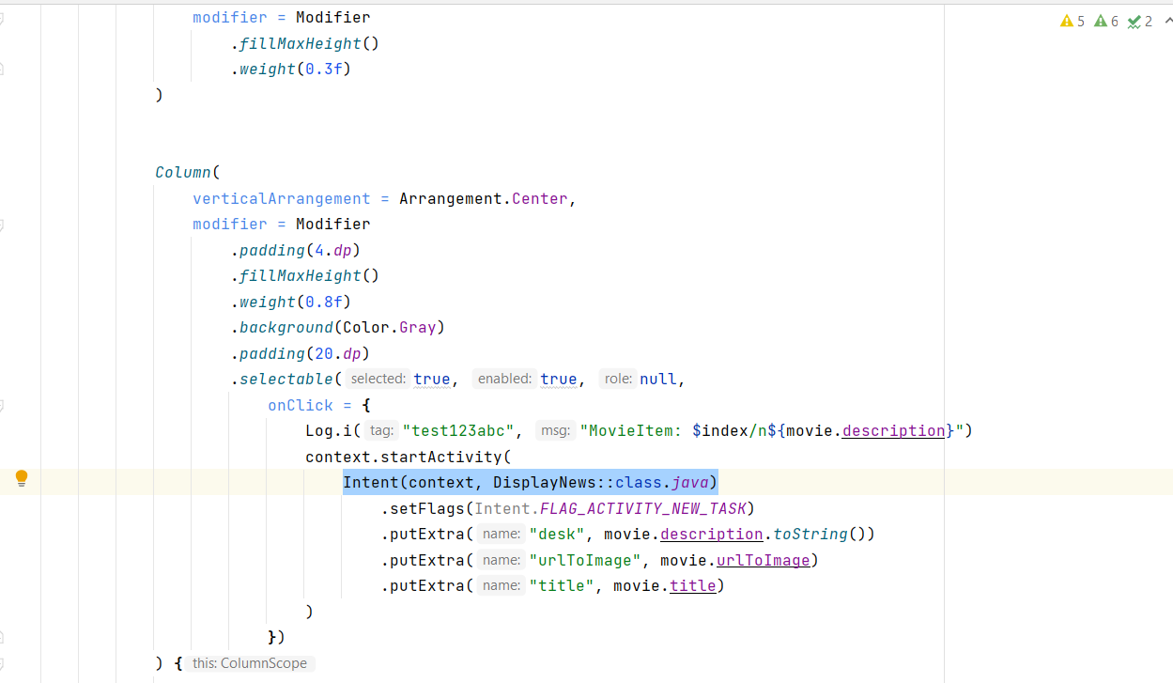

**Creating DisplayNews.Kt File**

**Creating DisplayNews.kt file**

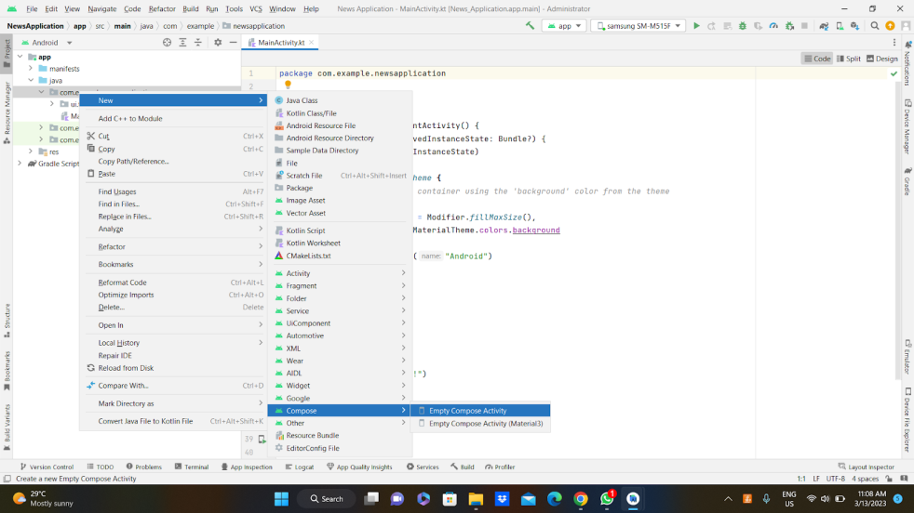

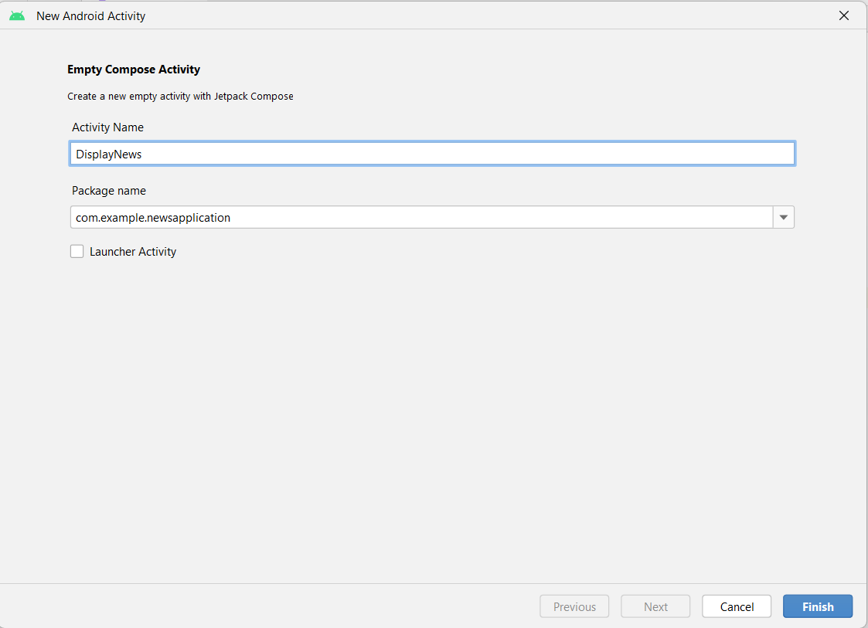

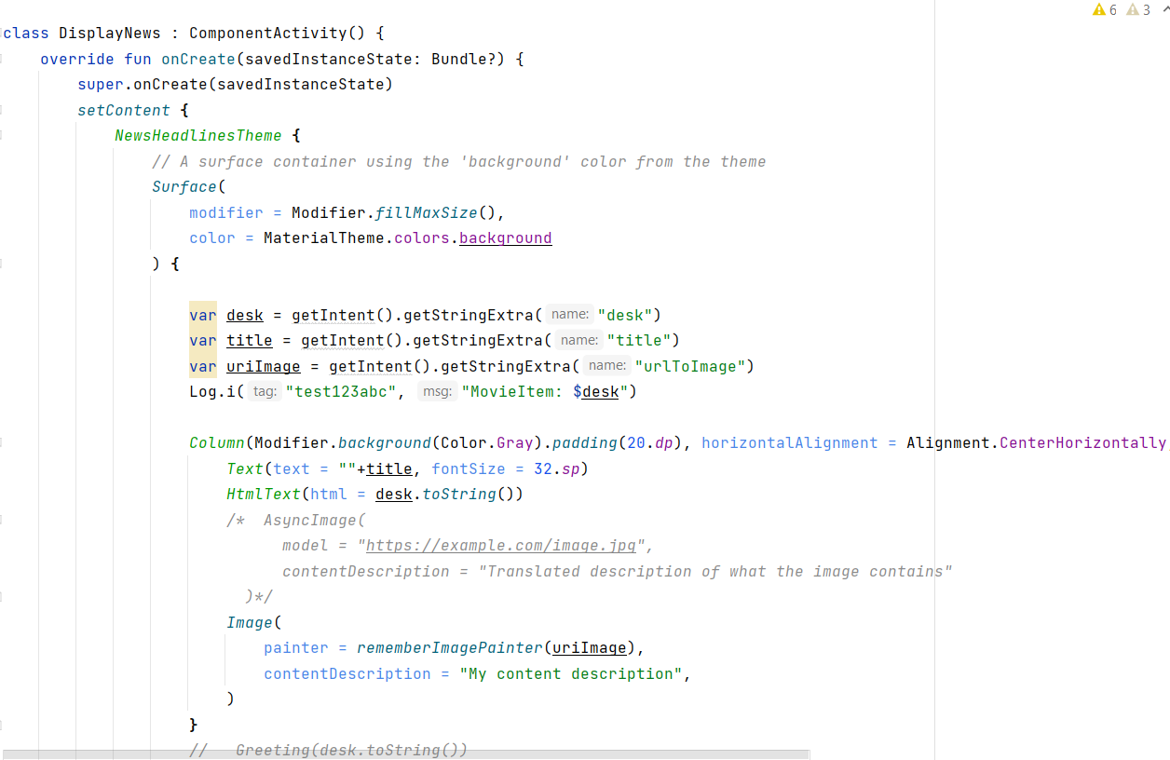

**Complete DisplayNews.kt code:**

<https://github.com/smartinternz02/NewsHeadlines/blob/main/app/src/main/java/com/example/newsheadlines/DisplayNews.kt>

**Modifying AndroidManifest.Xml**

**Modifying AndroidManifest.xml**

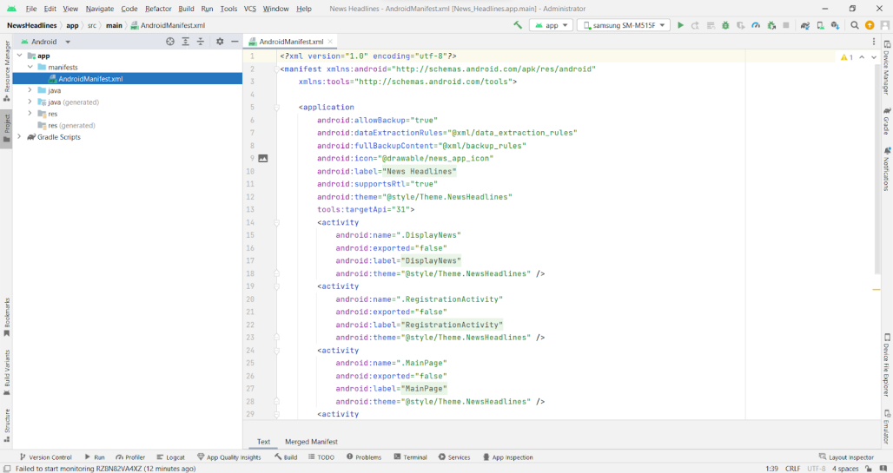

When we run the app we will get the MainActivity.kt file as our first screen , but we want LoginActivity.kt , So we need to change in AndroidManifest.xml.

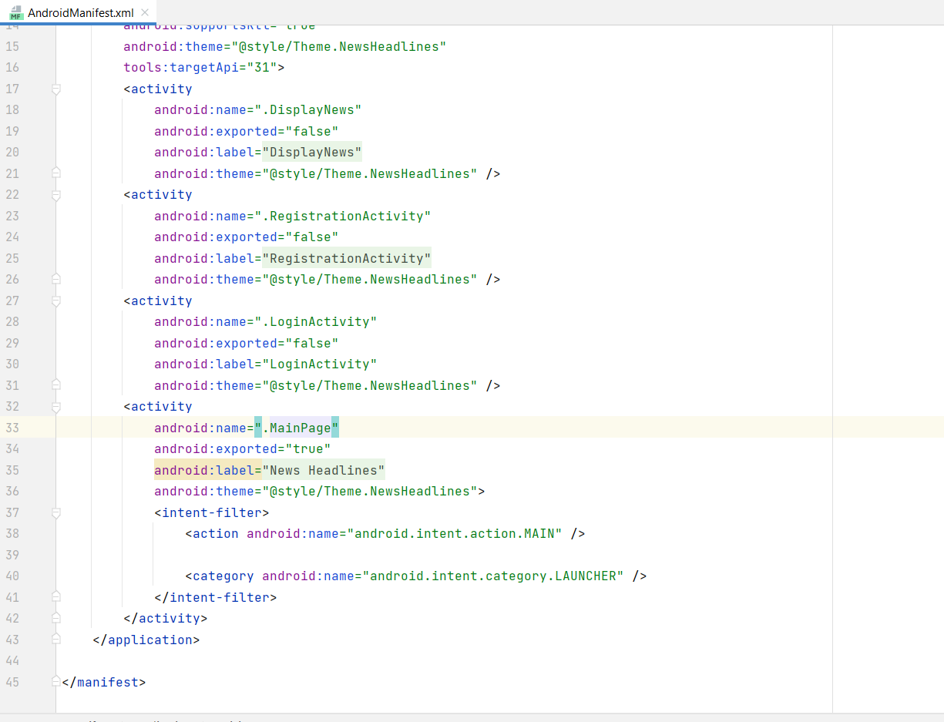

**Changed AndroidManifest.xml.**

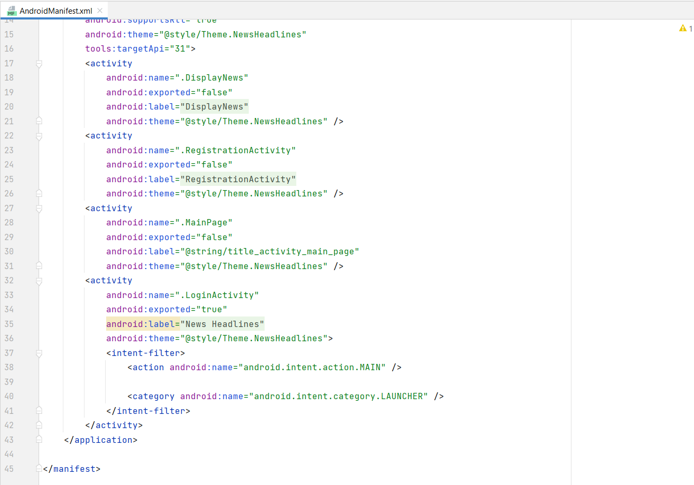

Complete code is given below:

<https://github.com/smartinternz02/NewsHeadlines/blob/master/app/src/main/AndroidManifest.xml>

**Running The Application**

This milestone explains about Running the application.

**Run Apps On A Hardware Device**

**Run apps on a hardware device**

<https://developer.android.com/studio/run/device>

**Run The Application In Mobile**

**Run the application in Mobile**

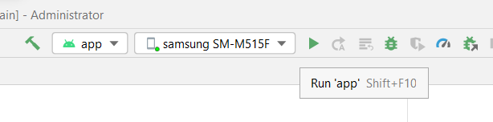

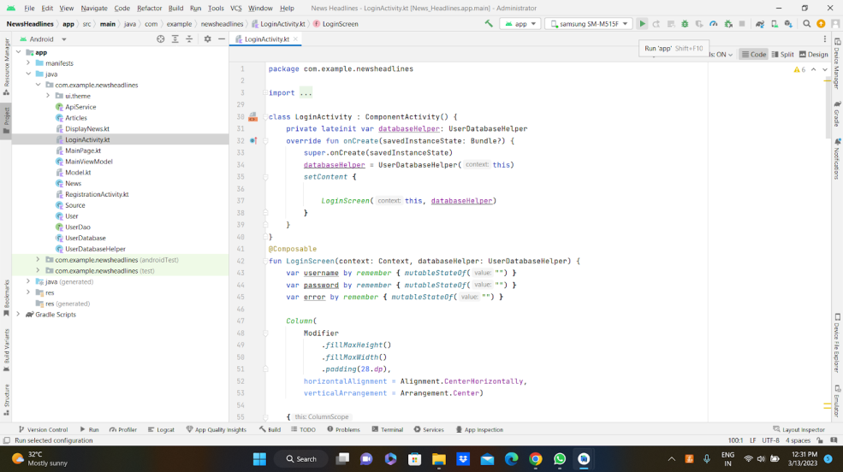

**Complete Project Link:** [**https://github.com/smartinternz02/NewsHeadlines**](https://github.com/smartinternz02/NewsHeadlines)

**Final Output of the Application :**

Login Page:

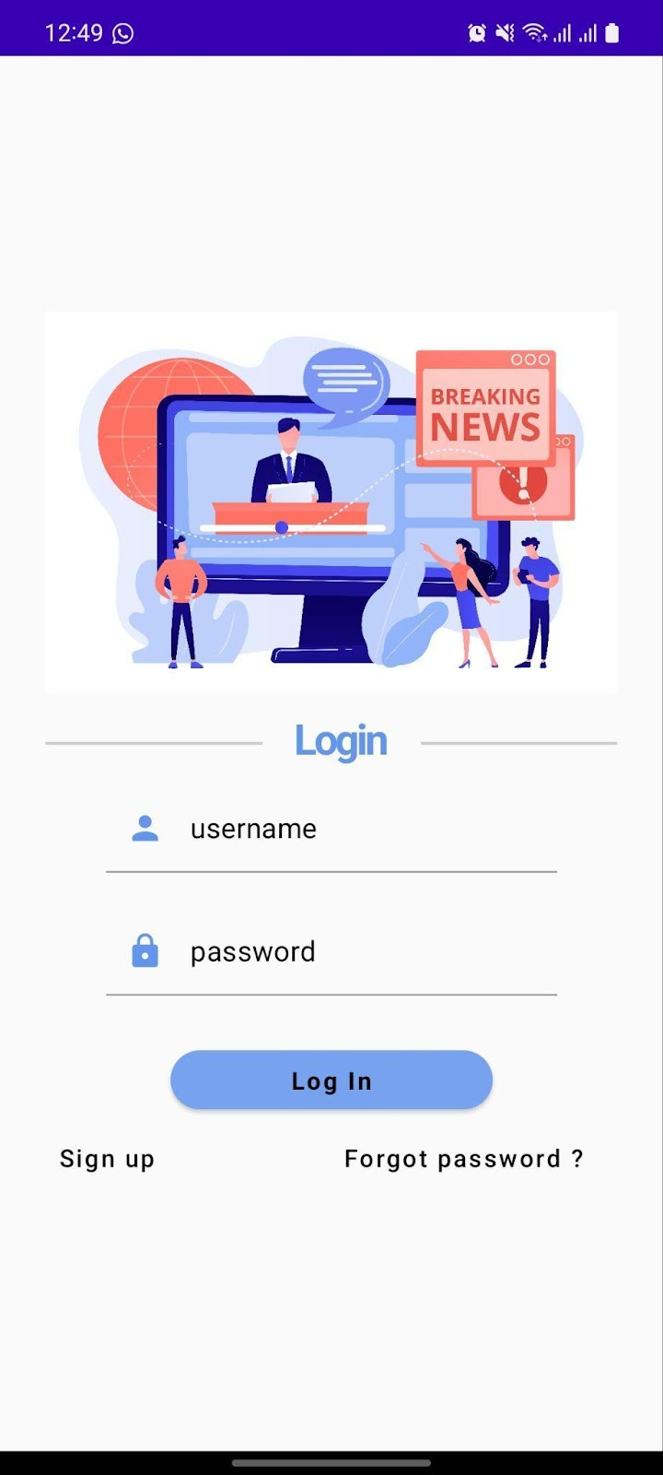

**Register Page :**

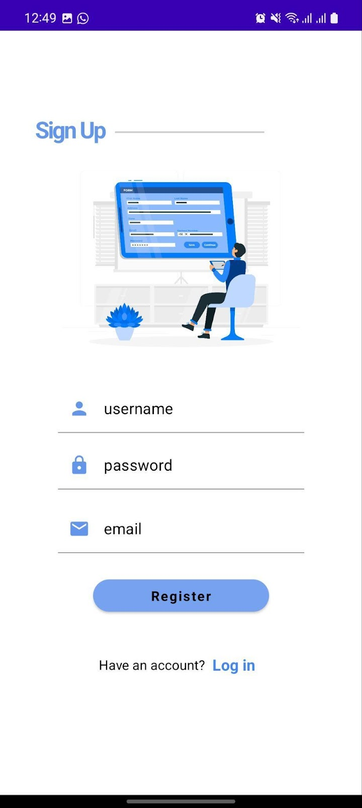

**Main News Headlines Page :**



**Display News Page :**

